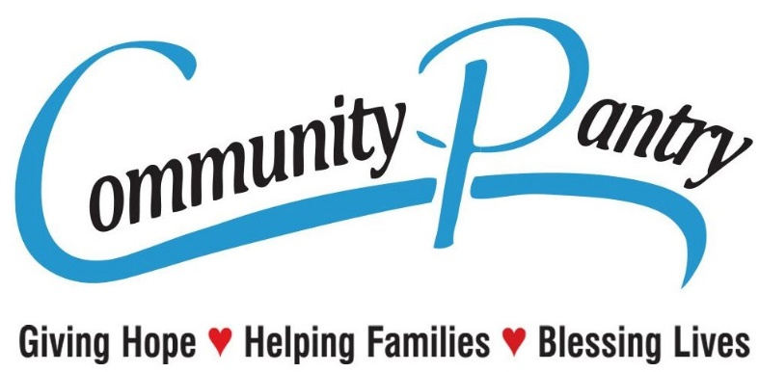

MANDATORY DOCUMENTS REQUIRED
(Effective November 18, 2017)

- Rental Agreement and a copy of a utility bill with the same address, or if renting a room only a signed pantry form from the property owner (Pantry Room Rental Form Required). If no rental agreement or if you own your home, we will need 2 utility bills with your address.

- Proof of All Income:
  - Passport to Services from DPSS which includes Cash Aid and Foods Stamps (Current Month). We will no longer accept NOA for Cash Aid and Foods stamps!!
  - Current Check Stubs for One Month Income
  - Unemployment Check Stubs / Denial Letter
  - Social Security Award Letter (Current Year)
  - Income in Kind and/or Sworn Statement of
  - cash earnings. (Sign Pantry Affidavit Form)
  - Court Ordered Child/Spousal Support
  - Retirement, Annuity, School Grants

- ID's & Social Security cards for All Adults (18 years and older) IN THE HOME

- SS Cards (U.S.A. born) or Birth Certificates (born out of the U.S.A.) for all CHILDREN under 18 years in the home

- Head of household must apply for assistance.

